**Work Breakdown Agreement**

|  |  |
| --- | --- |
| **Functionalities in charge of individually:** | **Person in charge** |
| Breeding, Pregnancy and Lay Egg  Egg  Stegosaur bush killing  DinoActor, Stegosaur, Brachiosaur, Allosaur  DinoEncyclopedia  movement package  Pterodactyls  Recommendations for extensions to the game engine | Joanne |
| Hunger & Feeding  AttackAction (Allosaur / Player attacks Stegosaur - implemented in Stegosaur)  Death (Corpse)  Unconsciousness  Allosaur corpse feeding  Thirsty dinosaurs  Second map | Jonathan |
| Player - anything about how player can interact with other actors/ items /ground  BuyAction, VendingMachine, EcoPoints, LaserGun  Player FeedAction, CheckInventoryAction SearchItemAction  Fruit, Bush, Tree, Dirt, MealKitsItem  Utility  Lakes, water and rain  A more sophisticated game driver | Nelly |

|  |  |
| --- | --- |
| Item | Due by |
| Complete code for individual parts and at least did some basic testing | 17th May 2021 |
| Complete testing of functionalities for project as a whole and write javadoc | 21st May 2021 |
| Update design artefacts as necessary | 24th May 2021 |

Signed by:

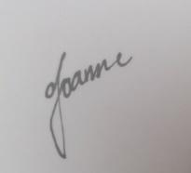

I accept this WBA.

(Joanne Ang Soo Yin)

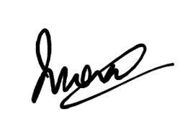

I accept this WBA.

(Jonathan Wong Leong Shan)

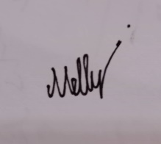

I accept this WBA.

(Nelly Tay Yee Ting)